
OWNER/OPERATOR'S MANUAL
ELECTRIC SCOOTER
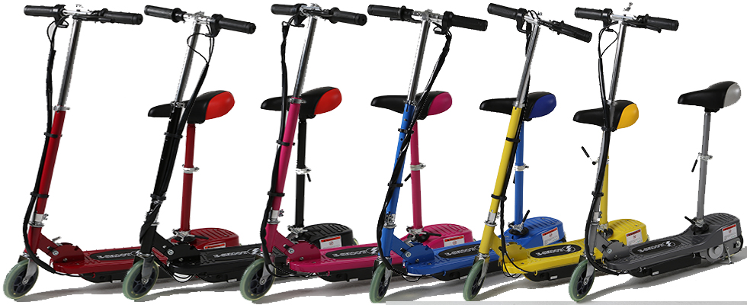
CAUTION: Read and understand this manual thoroughly before operating and handling the E-SKOOT, please follow all safety procedures and warnings to reduce the risk of riding the scooter
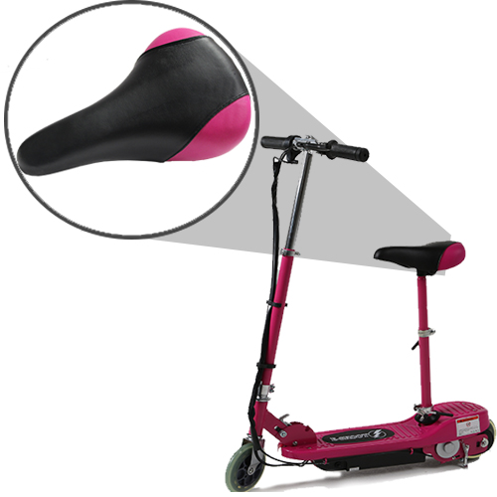
WARNING:
24V electric operated toy!
Not recommended for children under age 14 years old.
ALWAYS WEAR A SAFETY HELMET AND OBEY ALL LAWS!
Important battery information:
Once you've received your item please make sure that you FULLY charge the scooter for the first time you charge it for the suggested length (stated in your manual). If you only charge the scooter for half of the stated time the battery's memory cells will remember this, then when it comes to future charges it will not charge for any longer than this. Charge the scooter for the full charge time for maximum usage.
We also suggest giving the item a full charge after each use. If the scooter is not being used for a long period of time please charge the scooter once a month or disconnect the battery otherwise this could damage the battery.

Thank you for your purchase of the E-SKOOT Electric Scooter.
The scooter will provide you with hours of fun. The scooter is an eco-friendly choice of transportation since it is pollution free and whisper quiet. The scooter is completely portable with the quick fold mechanism. You can either store it in the car or take it with you on the train, or even in the bus!
Your scooter will provide best results on a smooth and flat terrain. You can always assist your scooter to start by pushing it like any other traditional scooter. Please be sure to operate your scooter safely and be aware of pedestrians. Be observant of all local and state laws according to scooter usage.
Make sure to pay attention to ALL safely warnings and cautions noted in this manual.

CAUTION: Read and understand this manual thoroughly before operating and handling the E-SKOOT, please follow all safety procedures and warnings to reduce the risk of riding the scooter


IMPORTANT SAFETY
WARNINGS

Before you attempt to ride the scooter, please read and ensure that you have understood the following instructions:
- Never ride the scooter on public streets or roads. Check local ordinances where riding is permissible.
- The minimum age recommended for riders is 14 years old. Maximum rider weight is should not exceed 70 kgs.
- The user of this product assumes ALL risks associated with its use. To minimize these RISKS, the user must wear safety helmet, goggles, gloves, elbow and kneepads and appropriate footwear (never go barefoot)…Be Cool But Be Safe!!!
- Avoid riding on gravel, sand, grass, slick or wet surfaces. The scooter performs best on smooth dry surfaces as it is designed to be used there only.
- This product is ELECTRIC! DO NOT ride this product in wet conditions, puddles or rainy weather.
- Never ride the scooter over curbs or jumps .This scooter is not designed for this type of riding. The retailer, distributor, importer and manufacturer will not be responsible for any injuries to the rider or damages to the scooter that occur from these types of activities.
- The brake is designed to control speed as well as stopping.
- Never ride the scooter with more than one person. Multiple riders could lead to lose of control.
- Keep hands, feet, hair & Shoe laces away from moving parts.
- Never leave children unattended with the scooter. This could lead to potential hazards.
- Familiarize yourself with the scooter and check all fasteners for tightness before each use.
- Do not store batteries near high temperature - batteries might explode.
- Do not expose charger to moisture or use it if it is damaged. Regularly check it's cord, plug and enclosure for any damage. The charger must not be used until the damage is repaired.
- Never operate scooter while it is impaired.
- Persons without excellent vision, balance, coordination, reflex, muscle and bone strength and good decision-making capabilities should not use this product.
- User: 14+ ages, should use the product with adult supervision at all times.
- Minors should not use this product.
- Persons unwilling or unable to take responsibility for their own actions should not use this product.
- This product is ELECTRIC! DO NOT ride this product in wet conditions, puddles or rainy weather.

·IMPORTANT! It is always recommended to start the Electric Scooter by pushing, thus to reduce the start load on the motor. Your scooter would have a much longer lifetime with push assistance.

IMPORTANT注意
BATTERY MAINTENANCE and CHARGING INSTRUCTIONS

You MUST charge completely prior to initial use.
(Follow charging instructions in your Product Handbook)
- Charge immediately after each use.
- Charge before storage. You must charge every 30 days if not in use. Charge the unit for 6-8 hours until the light on the charger turns green.
- DO NOT allow the battery to fully discharge.
- For safety purposes, DO NOT charge for over 8 hours.
- DO NOT overcharge the batteries refer to charging times above
- Inspect batteries occasionally and keep the terminals clean and connections tight
- Turn the unit OFF when not in use.
Failure to follow these INSTRUCTIONS will
VOID YOUR WARRANTY!
不
This PRODUCT IS NOT INTENDED FOR EXTREME or
OFF-ROAD Use! Please take care of your ELECTRIC SCOOTER!
DO NOT JUMP or ABUSE THIS PRODUCT!
DO NOT RIDE IN WET/ICY CONDITIONS!
DO NOT RIDE INDOORS
The appliance is not intended for use by persons (including children) with reduced physical, sensory or mental capabilities, or lack of experience and knowledge, unless they have been given supervision or instruction concerning the use of the appliance by a person responsible for their safety

PACKAGE CONTENTS
Your ELECTRIC SCOOTER comes with the following items in the box. Please locate all of the following

- The ELECTRIC SCOOTER
- Battery Charger
- Tool Kit
- Product Handbook

GETTING STARTED

Please read and understand these instructions and the OPERATING PROCEDURES section, prior to starting or riding your ELECTRIC SCOOTER
Assembly

- Carefully remove your scooter from the box.
- Install the front wheel.
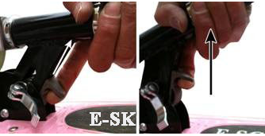
- To unfold the scooter, begin by pressing the grey plastic lever up on the FOLDING HANDLE with one hand, while gently pulling up on the handlebars with the other. The handlebar will snap into place and will not move when secured properly.

- Loosen the handlebar clamp, and raise the handlebar to the desired height, being sure the pole snaps into place. Then tighten clamp securely.

- To attach the handlebars to each side of the t-bar, first loosen the top handlebar clamp then slide each handlebar into the t-bar being sure they snap into place and are in the correct orientation for riding. Finish by clamping down the clamp lever securely.

Charging

WARNING: Do not allow your scooter to go into deep discharge, as this will damage the batteries.
- Make sure unit is turned off.
- Charging socket is located on side. (see picture below)
- Locate your Battery Charger. Find the charger socket end that has a single-prong socket and plug it into the scooter.
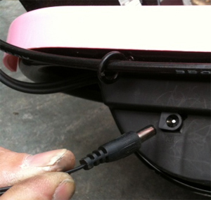
- Next, plug the AC plug into a 220/240 Volt electrical wall outlet.
- When first plugged in, the charger will have one red light that will illuminate as long as the power switch is in the charge position, if the power switch is in the on or off position the charger will have a red and green light illuminating which means no charge is taking place. Make sure you have the switch in the correct charge position. After 4-8 hours the green light on the charger is illuminated indicating the unit is now fully charged. Make sure to replace the cap over the charge socket.
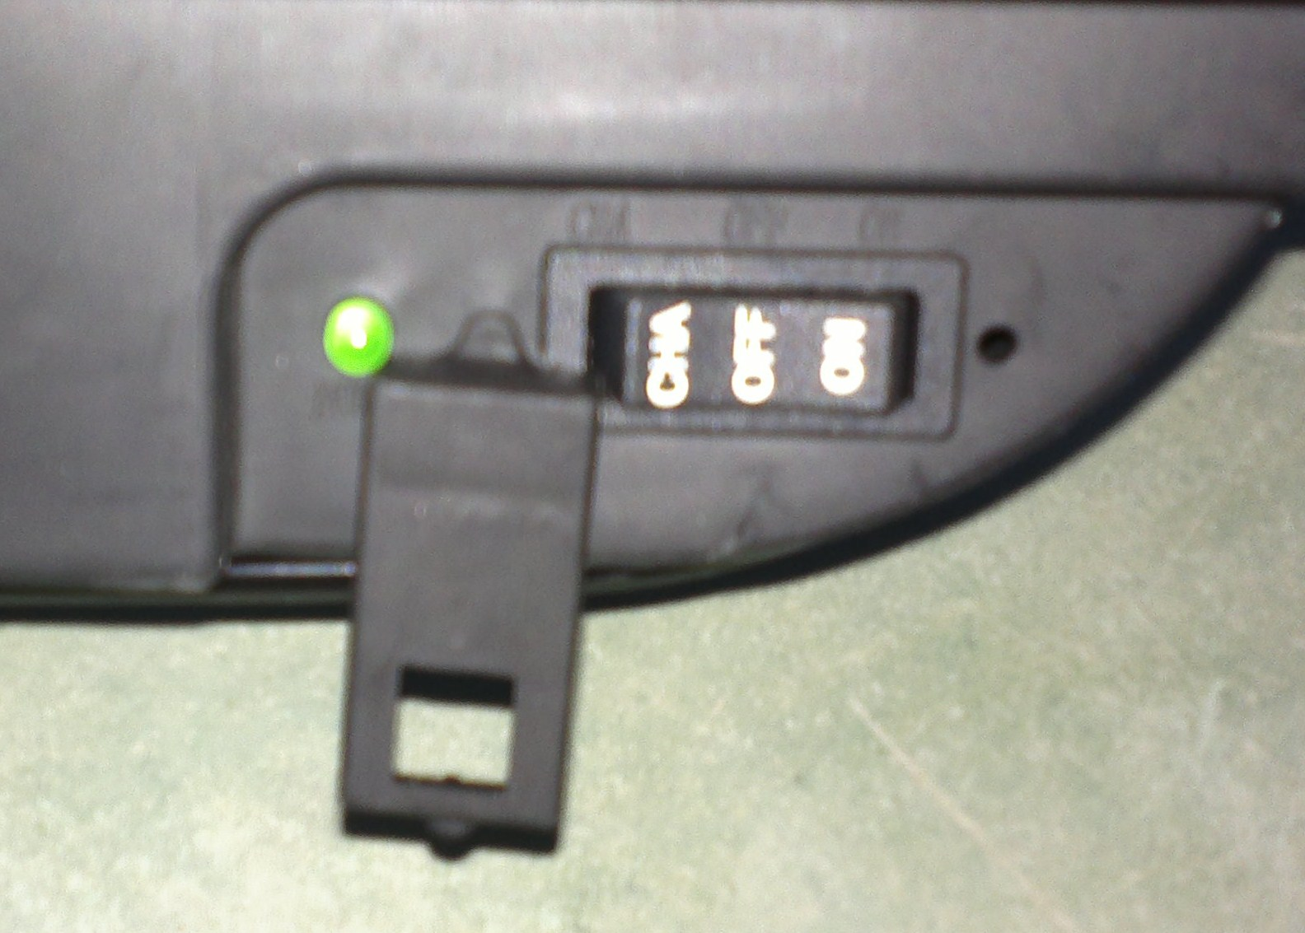
3 Shifts Switch with Power-off protection
1. Turn on: press “ON” shift (When press “ON” shift, the circuit of batteries, controller and other parts are connected, then you can operate the scooter)
2. Power off: press “OFF” shift (When press “OFF” shift, the circuit between batteries and controller are completely disconnected, this will protect the batteries’ lifetime and performance.)
3. Charging: press “CHA” shift (When press “CHA” shift, the circuit between battery and charging system are connected, but disconnected from the controller system, the scooter can only be charged in this status,
CHARGING
When shipped, the batteries may be fully charged. Charging the batteries after every use is recommended. For extended battery life, avoid discharging batteries before they are completely recharged. Lastly, follow this one simple use: When the scooter starts to slow down on level ground, it is time to recharge. Avoid running batteries completely flat.
IMPORTANT
To ensure that the batteries are fully charged between uses but not over-charged, please follow the recommended charging times. Battery overcharging does not result in longer running time; however, it merely damages the batteries and reduces their lifespan.
Power use can depend on types of ride, times are recommended averages.

E-Skoot use time (battery discharging) | Charging time (don't overcharge)
0-minutes | 4-6 hours
20 minutes | 6-8 hours
30minutes | 8-10 hours
RANGE AND SPEED
When fully charged the scooter will cover approximately 15 km on level ground, with a 70 kg rider. The top speed is approximately 15km/h with a 70kg rider on level ground and calm winds. Please note that these figures are estimates only thus, they may vary.

Circuit Breaker

When the current is too high, the fuse will pop up, you only need to press it down, the scooter will work again, there is no need to change the fuse
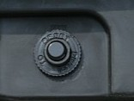

Riding

- Make sure that all of the exposed bolts and screws are tightened.
- Raise the kickstand to its up position.
- Push the on/off switch to the ON position
- Put one foot on the deck of the ELECTRIC SCOOTER while pushing off with the other foot, gently rotate the THROTTLE GRIP, on the right side of the handlebars. The ELECTRIC SCOOTER will begin to move on its own power.

Your scooter has a variable speed hand throttle. You can control the speed of your scooter by the amount of pressure you use when rotating the hand throttle. The more you rotate, the faster you will go.

Please ensure this small grub screw is secure and tight using the small allen key provided.
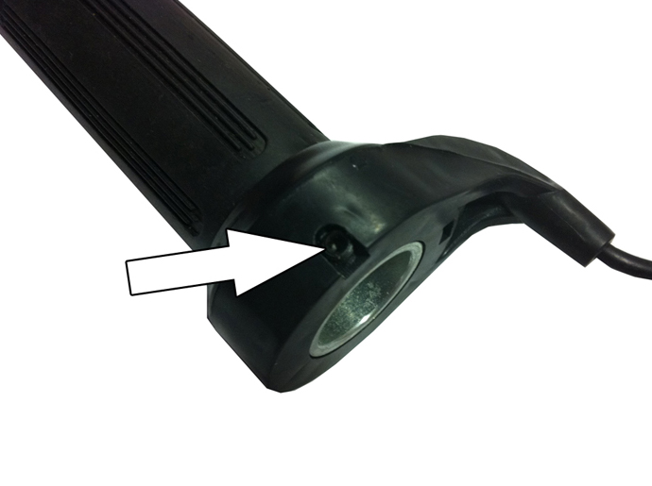
Stopping/Braking

To brake, release the THROTTLE GRIP and depress the BRAKE LEVER on the left side of the handlebars. Depressing the brake will disengage power to the motor. When the unit is loosing power or not accelerating to full speed, the scooter is ready to be re-charged.

Brake System

The ELECTRIC SCOOTER uses a hub brake system on the rear wheel. A hand brake lever on the left side of the handlebar activates the brakes. Squeezing the hand brake lever with your left hand will activate the rear brake. Make sure to release the HAND THROTTLE GRIP when engaging the brakes.

Practice braking on a smooth, dry surface to get used to the feel of the braking system. Braking distance is affected by wet conditions and loose and uneven riding surfaces.

Adjusting the Brakes
The Brakes on the ELECTRIC SCOOTER should come fully adjusted from the factory. However, it may be necessary to adjust the brakes from time to time.
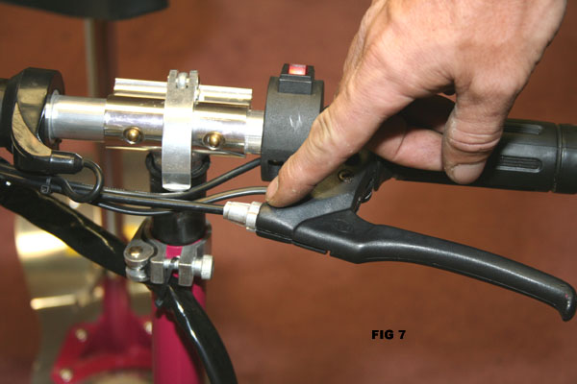
To adjust the rear brakes:
For brakes that are adjusted too tight

- Loosen the tension screw on the left hand brake lever by rotating it counter-clockwise until the wheel spins freely.

For brakes that are adjusted too loose

- Tighten the tension screw on the left hand brake lever by rotating it clockwise until the wheel has a slight drag.

- For further adjustment, locate the adjustment screw on the rear brake hub located on the rear wheel.
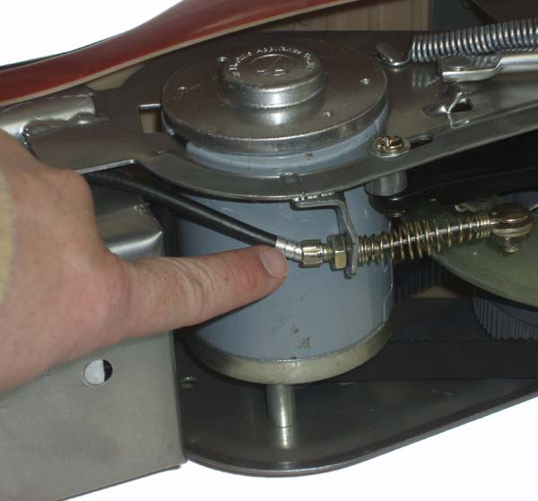

Squeaky Brakes

The brakes may squeak before they are broken in. T ot affect the function or performance of the brakes. With continuse go

The brakes may squeak before they are broken in. This is normal and will not affect the function or performance of the brakes. With continued use the squeak should go away.

STEERING ADJUSTMENT NUTS
You will need to periodically check the steering for looseness. The tightness of the steering can be adjusted by turning the round nut clockwise, and locking the hex nut
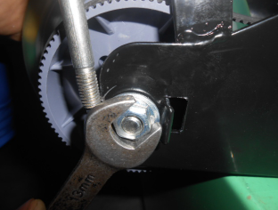
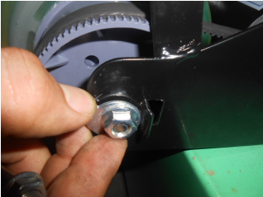

MAINTENANCE

RECOMMENDED TOOLS

To adjust and service the ELECTRIC SCOOTER you will need the following tools:

- Allen Wrenches: M5，M2.5
- Wrenches: M13-15，M8-10
- Large Adjustable Crescent Wrench
- Philips Head Screwdrivers
- Oil, Grease or Lubricant

MAINTENANCE SCHEDULE

Proper care of your ELECTRIC SCOOTER will insure optimal performance and longer life span. The following are a few maintenance suggestions that will keep your ELECTRIC SCOOTER running in top condition:

Daily Maintenance
Perform each time before you ride your ELECTRIC SCOOTER
- Clean the exterior of the unit with a soft, damp rag.
- Check that all nuts and bolts are securely tightened.
- Check battery charger for any frayed/cut wires.

Trouble shooting

Troubles | Possible Causes | Suggest Solution
1) Poor acelaration or low maximum speed | ---Too low voltage | Charge the battery immediately
2) switch in the on position, the scooter does not work | ---The wiring between the batteries are loose  ---The current too high  ---The inner cables of the scooter are loose or damaged  ---Batteries not connected properly | ---connect the wiring  ---press the Circuit breaker, and then switch scooter on  ---connected cables  ---Check all connections
3) Poor Battery Life | ---didn’t charge for full time or the charger has problems ---the battery is aging or damaged --- frequent brake and starting or overloading | --- Charger faulty or poor connections check whether the connection of the plug of the charger is good ---Change the battery
4) The charger doesn’t work | ---The plug of the charger drops off or the connection between the plug and socket is loose | --- Fasten the plug and connector
5) other troubles | ---when you meet other troubles you can’t solve or judge under the guildness ---when the elements of the electric machine, controller, charger or battery are damaged | Please contact the dealer or local repair station. Don’t open the above component; otherwise you may loose our warranty.
6) Insufficient Range | 1. Batteries not fully charged  2.Hilly terrain  3.batteries are cold  4.Damaged or old batteries | 1.Charge batteries  2.push firmer when starting  3.warm batteries gently  4.Replace batteries

REMOVABLE PLATFORM
The platform is removable to gain access to the batteries. Simply remove the four deck screws with a Phillips screwdriver, and lift off the platform. Reverse procedure to replace platform.

DRIVE BELT ADJUSTMENT AND REPLACEMENT
Periodic adjustment of the drive belt is required. The belt will loosen after long period of operation. When this happens, the belt will make a popping sound while accelerating. When this occurs, you must tighten the drive belt immediately. To tighten the belt, slightly loosen near rear axle nuts and rotate the belt adjuster discs equally. Tighten axle nuts and recheck belt tension.
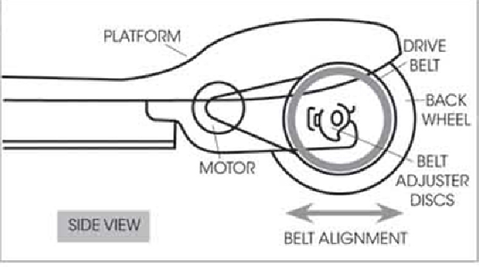
DRIVE BELT ALIGNMENT
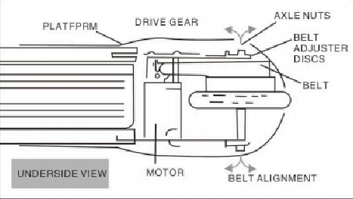

If you experience either the drive belt coming off the drive gear or the wheel gear and/or rubbing against the scooter frame, there most likely is belt misalignment. To re-align, carefully place the scooter upside down on a sturdy surface and determine the direction of the belt-side movement. You will slightly need to move the rear wheel left or right to re-align. To do this slightly loosen axle nuts and rotate the belt adjuster discs. Tighten axle nuts and check alignment by engaging power. Recheck alignment after riding; readjust if necessary.


Customer Service
TEL: (0161)220-1746
info@eskooters.com

